**User guide:**

**Header:**

This part will always be on the top of the web page. From this section, user can easily switch to other main pages



**Footer:**

Link to home page, contact page, q&a, news

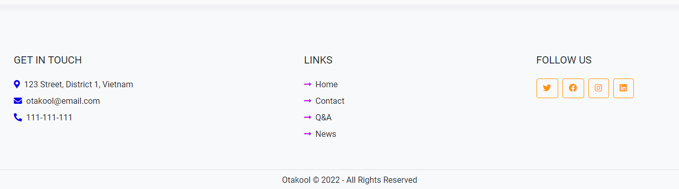

**Product List (Manga, Anime, Figures, Merchandise, Promotions):**

See available products, click on products to see details of products. You can filter or order the products through the sidebar option.

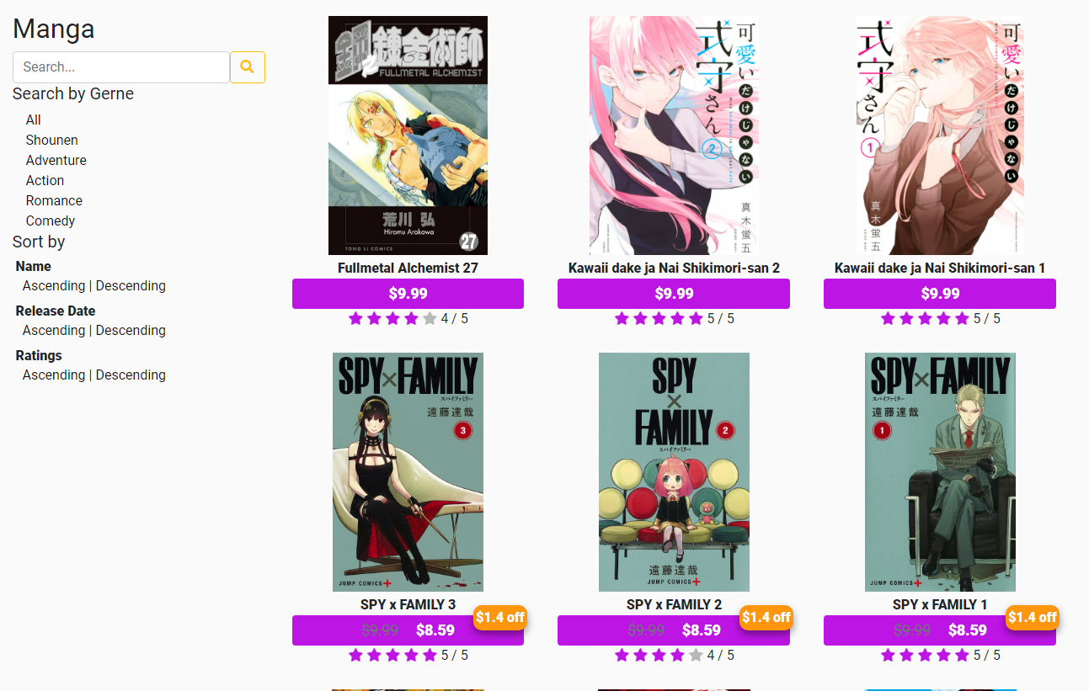

**Product details:**

Show details of products, click buy to go to cart (requires login). Scroll down to see comment section.

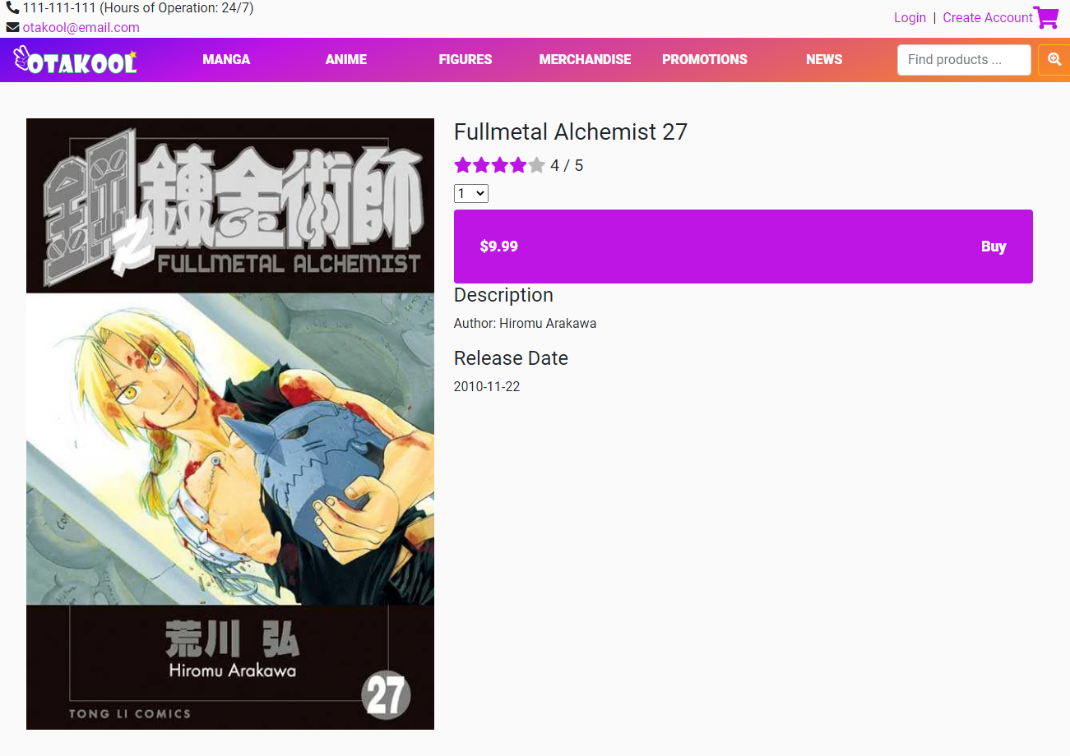

(product details)

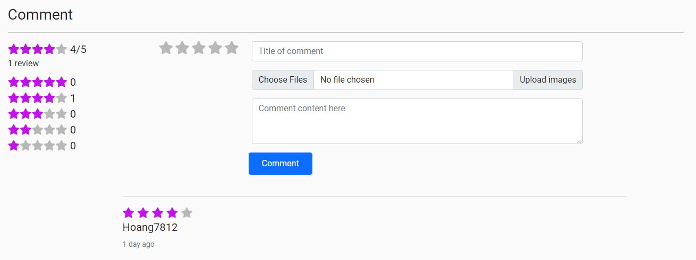

(comment section, login to comment)

**Cart:**

Cart button always at the top right of the website. Proceed to checkout if you decide to.

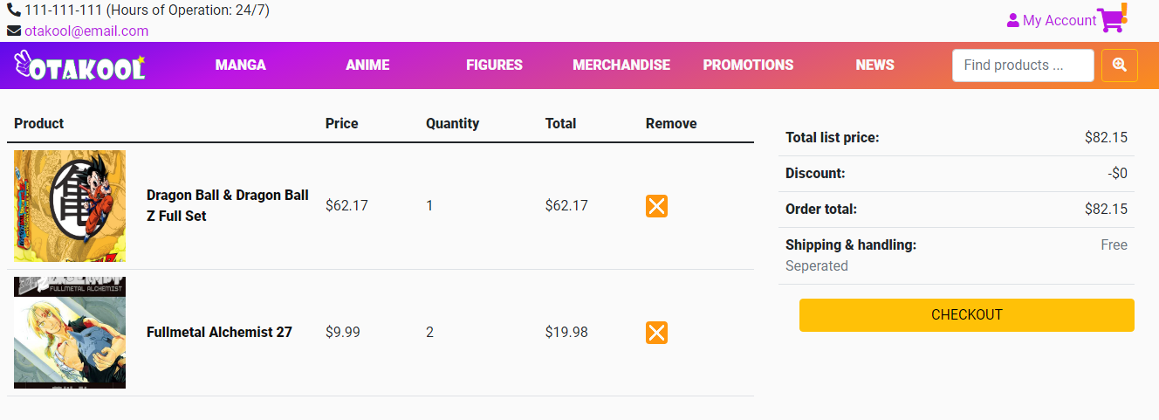

**Checkout:**

Input details for delivery and contact, if there are anything else you would like to let us know for the delivery please write in the “Note”.

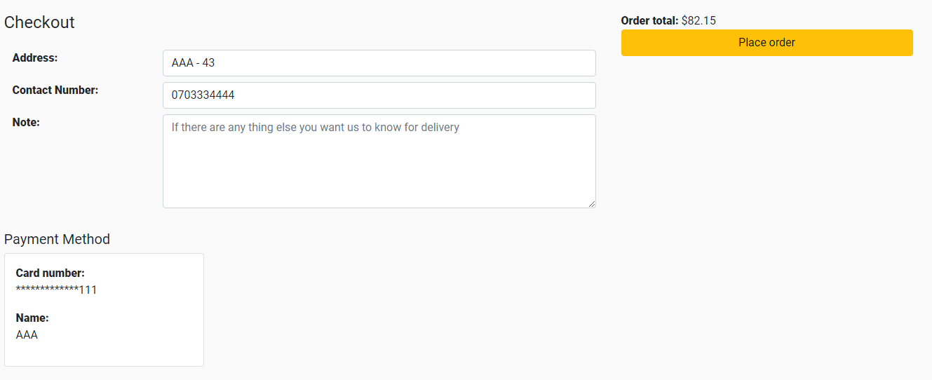

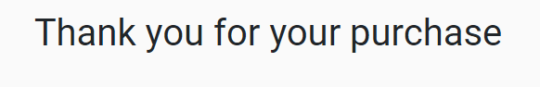

(After you press the Place order)

**News:**

See the latest news. Click on title to see details.

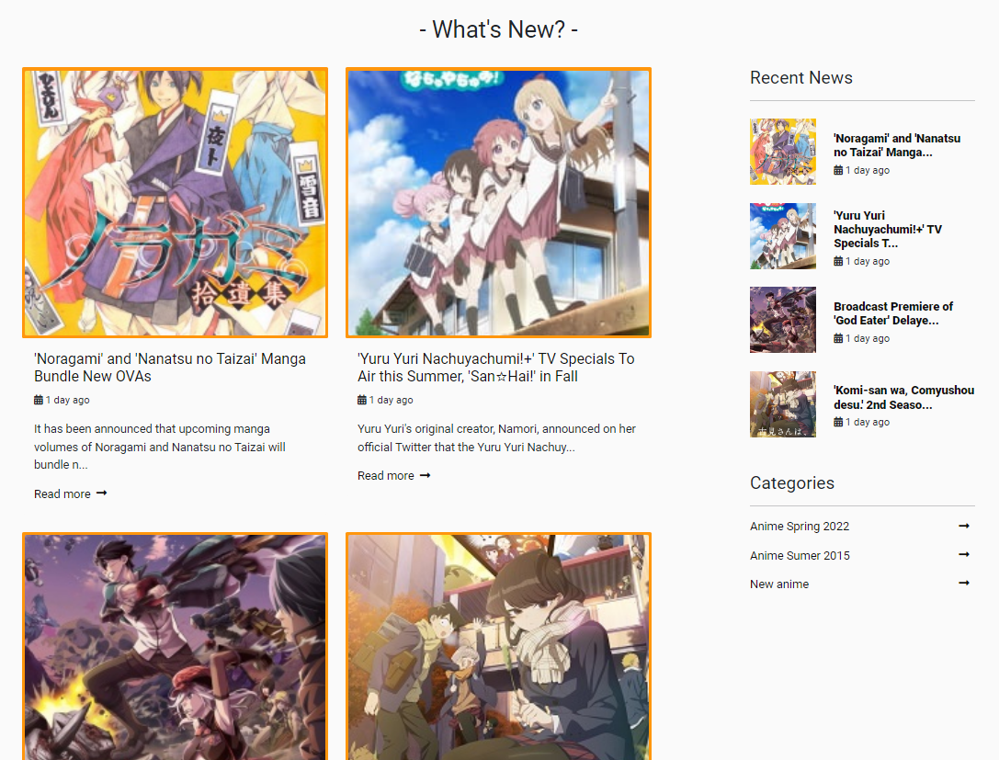

**News details:**

Show news’ details

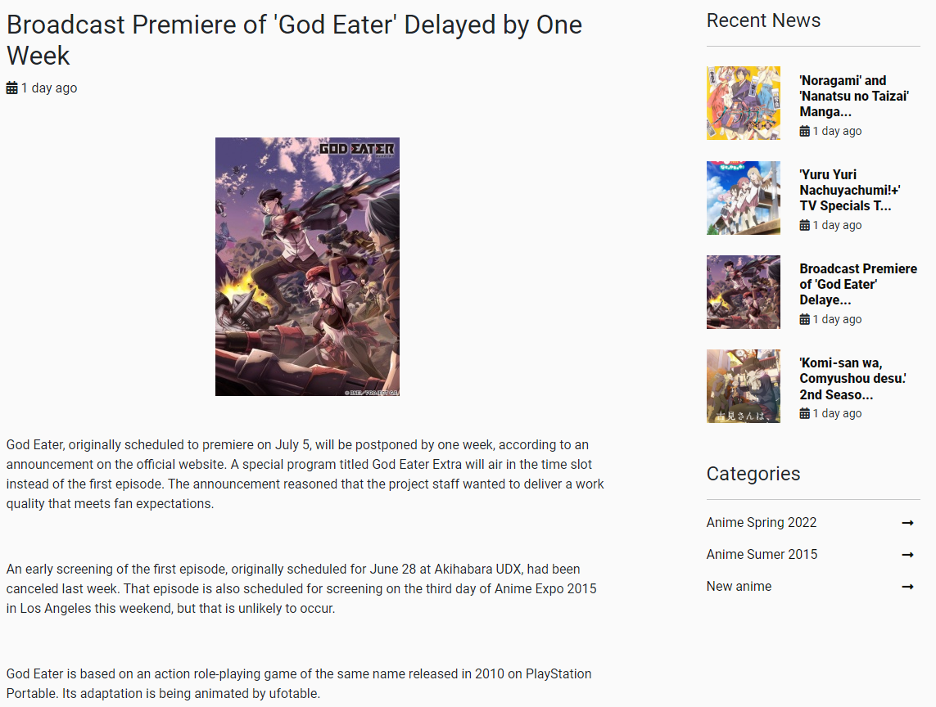

**Feedback:**

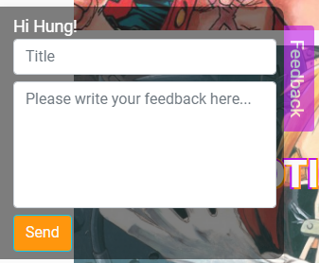Always at the bottom left of page (login to see). You can send feedback to us.

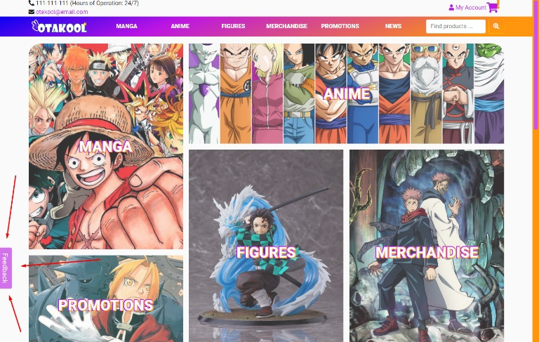

**Contact page:**

From footer link. Customers and guesses can contact us through this.

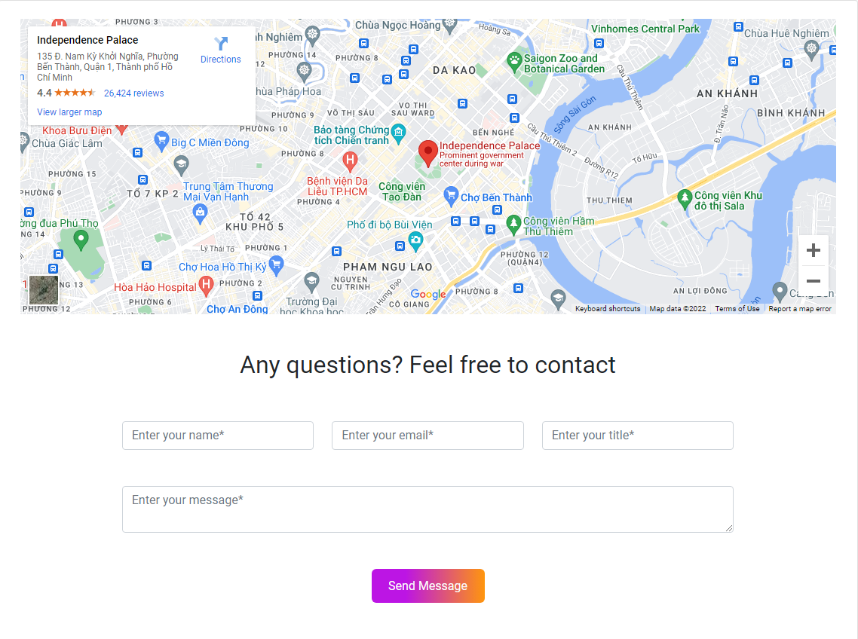

**Q&A:**

Frequently asked questions and answer.

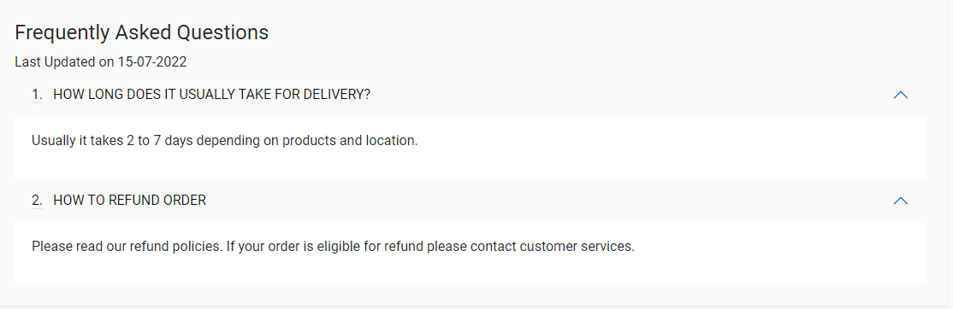

**Login:**

Login from header link.

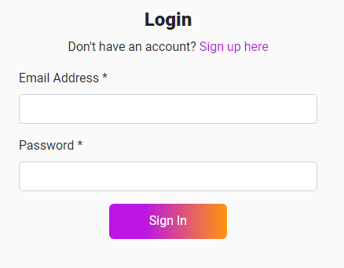

**Register account:**

You can create account through the link in header.

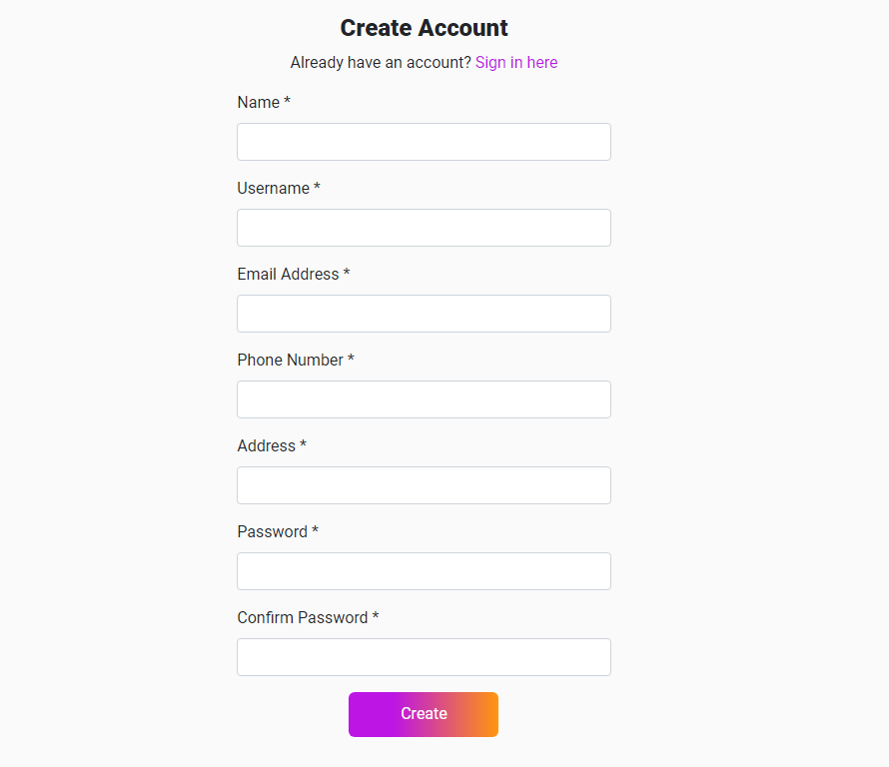

**Account details:**

See your own account details.

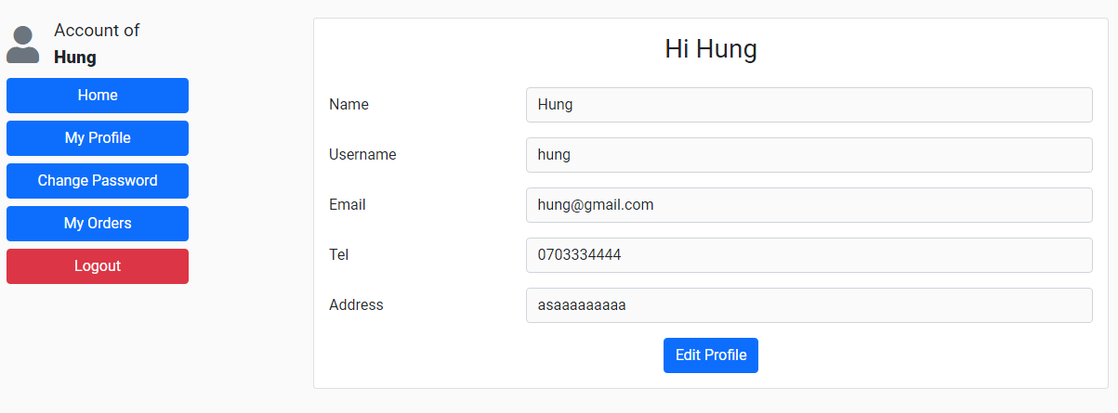

Edit your details

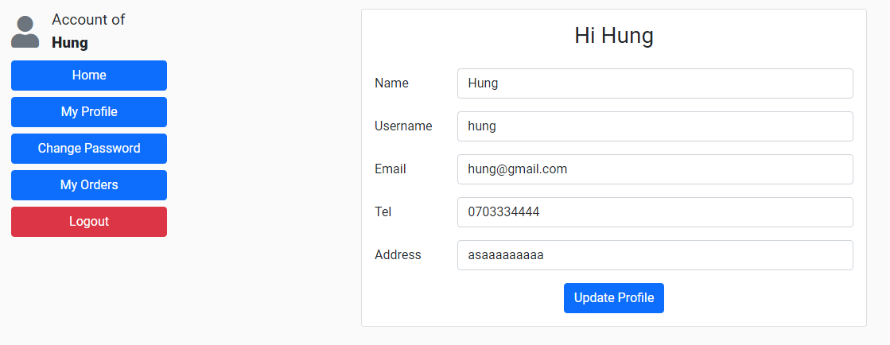

**My orders:**

See the orders you have made through the sidebar link

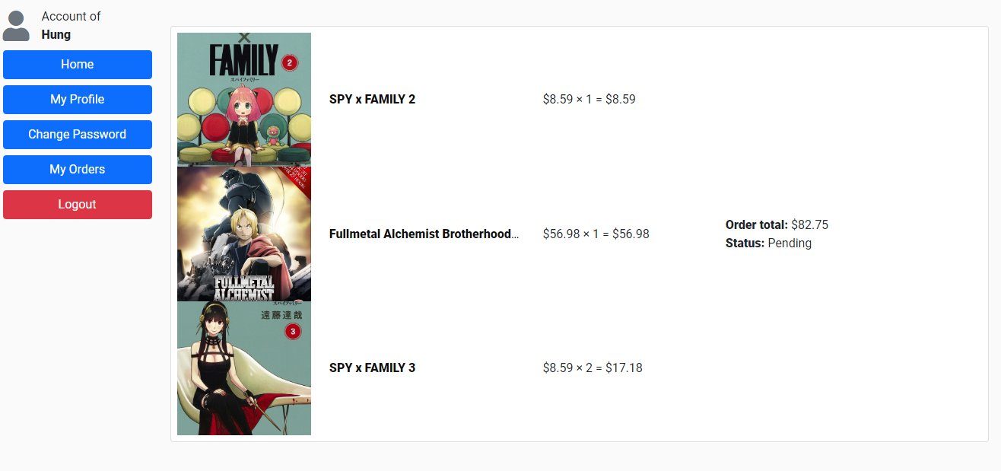

**Change password:**

Change your password through the sidebar link

